For ***Linkedlist*** you can do questions from **hackerrank**:

Link : <https://www.hackerrank.com/domains/data-structures?filters%5Bsubdomains%5D%5B%5D=linked-lists>

Guys do these questions.. this will make you understand the concept better and help each other with doubt …make friends 😊

You can ask doubt on slack.

ADD UP question :

Given a linkedlist of characters data nodes. Can you find if the linkedlist is palindrome or not

Example input:

a->b->c->b->a->null

this Is a palindrome hence return true.

Conditions :

Don’t use extra space == > space complexity = O(1)

(you can ask for more question on slack I can provide more if you are done with these.

For Array

Q-1

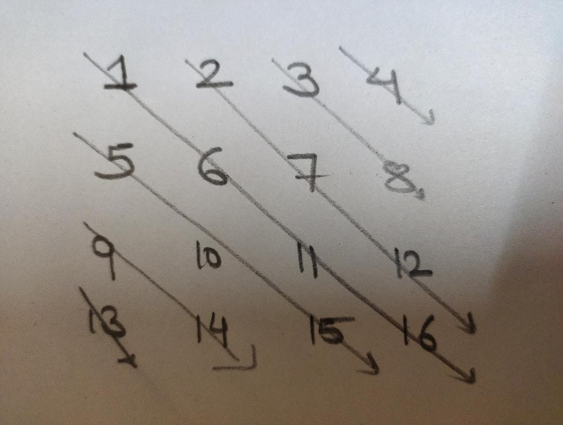

Given the 2d array print the 2d array in the following order.

Output format:

13

9 14

5 10 15

1 6 11 16 and so on….

(this is observation based question .. try finding the pattern and I will be uploading the solution on github also so you can refer if stuck)

Question :

Given a 2d array print the sum of all the possible subarrays of the 2d array;

Explaintaion:

You have to print the sum of all the 1X1 size array + sum of elemets of all 1X2 array + …+ sum(1Xn) + 2X1 arrays + ….

2Xn arrays + …….+ nXn arrays.

Try to optimize the solution as much as possible.

(beginners can skip the optimization part I will be discussing similar problem then you can try it)

Question :

Given an array A. Rotate the array with some factor k to the left.

Explaintaion:

A : 1 2 3 4 5 6 and K = 2

Requried output for this testcase:

3 4 5 6 1 2

Try analyzing time complexity of your code….

(if done try to optimize the solution … there is an algo to do this in O(1) time …(I can provide links for the same if you need just ask in slack) )